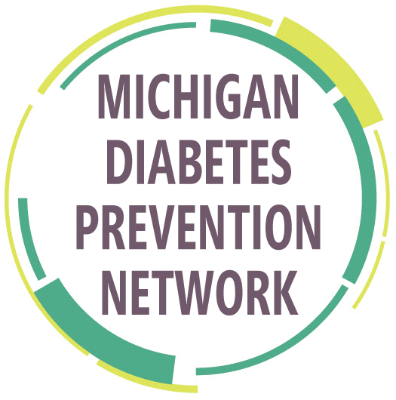
CDC Diabetes Prevention Recognized Program
Class Information Form

Instructions:
- Click in each box to select an option or type information.
- Email the completed form to: michiganDPP@gmail.com
- If the DPP is canceled or rescheduled, please notify michiganDPP@gmail.com

DPP Provider Organization (REQUIRED):
Is the organization’s DPP in “Recognized” or “Pending” status by the CDC?
Yes No Don’t know

DPP Provider Website: |  |  |  |  |  | Class Format:
Will there be an informational session for this DPP?  Yes No |  |  | Information Session Date: |  |  |  |  |  | Information Session Time:
First Session Date: |  |  | Class Meeting Day (m, t, w, th, f): |  |  |  |  |  | Session Time:  AM PM
Session Location:  Name:  Address 1:  Address 2:  City:  Zip:  County: |  |  |  |  | Registration Information (for public listing):  Contact Name:  Email:  Telephone:  Registration Link:
Location Type (choose from the dropdown list): |  |  |  |  | Registration Deadline:  *Listing will be removed after deadline
Registration submitted by (For registration questions from MDHHS):

Phone: Email: Date:
Other notes (Ex: Payment options, special population, max # of participants, etc.): |  |  |  |  |  |  |  | Language (If other than English):
For Office Use Only
Processed by: |  | Date: |  |  | Course ID: |  |  |  |  | Db Confirmation

